Arp spoofing

ARP (Address Resolution Protocol) spoofing is a type of cyberattack where an attacker sends falsified ARP messages over a local network. This attack allows the attacker to link their MAC address with the IP address of another device (such as the gateway), leading to:
- Man-in-the-Middle (MITM) Attacks: The attacker intercepts traffic between two devices.
- Denial of Service (DoS): Traffic gets redirected, causing network disruptions.
- Session Hijacking: The attacker can capture sensitive information.

Set Up the Network Topology
- Open Cisco Packet Tracer.
- Add the following devices:
  - 1 Router (Router0)
  - 1 Switch (Switch0)
  - 2 PCs (PC1 as the victim and PC2 as the attacker)
- Connect the devices using Copper Straight-Through cables:
  - PC1 to Switch
  - PC2 to Switch
  - Router to Switch

Configure IP Addresses
- Router Configuration (Router0)
  - Click on the router → Go to CLI → Enter the following commands:
enable
configure terminal
interface FastEthernet0/0
ip address 192.168.1.1 255.255.255.0
no shutdown
exit
- This assigns the router an IP address of 192.168.1.1.
- PC1 (Victim) Configuration
  - Click on PC1 → Go to Desktop → Click on IP Configuration.
  - Set IP Address: 192.168.1.2
  - Set Subnet Mask: 255.255.255.0
  - Set Default Gateway: 192.168.1.1
- PC2 (Attacker) Configuration
  - Click on PC2 → Go to Desktop → Click on IP Configuration.
  - Set IP Address: 192.168.1.3
  - Set Subnet Mask: 255.255.255.0
  - Set Default Gateway: 192.168.1.1

Verify ARP Table Before the Attack
- Open Command Prompt on PC1.
- Type the following command:
arp -a
- This displays the current ARP table.
- PC1 should associate 192.168.1.1 with the router’s MAC address.

Perform ARP Spoofing from PC2 (Attacker)
- Open Command Prompt on PC2.
- Run the following command to manually add a false ARP entry:
arp -s 192.168.1.1 00-11-22-33-44-55
- Replace 00-11-22-33-44-55 with PC2’s MAC address (Check in Packet Tracer by clicking on PC2 → Config → FastEthernet0).
- This tells PC1 that the attacker’s MAC address belongs to 192.168.1.1.
However static ARP is not allowed in cisco packet tracer.
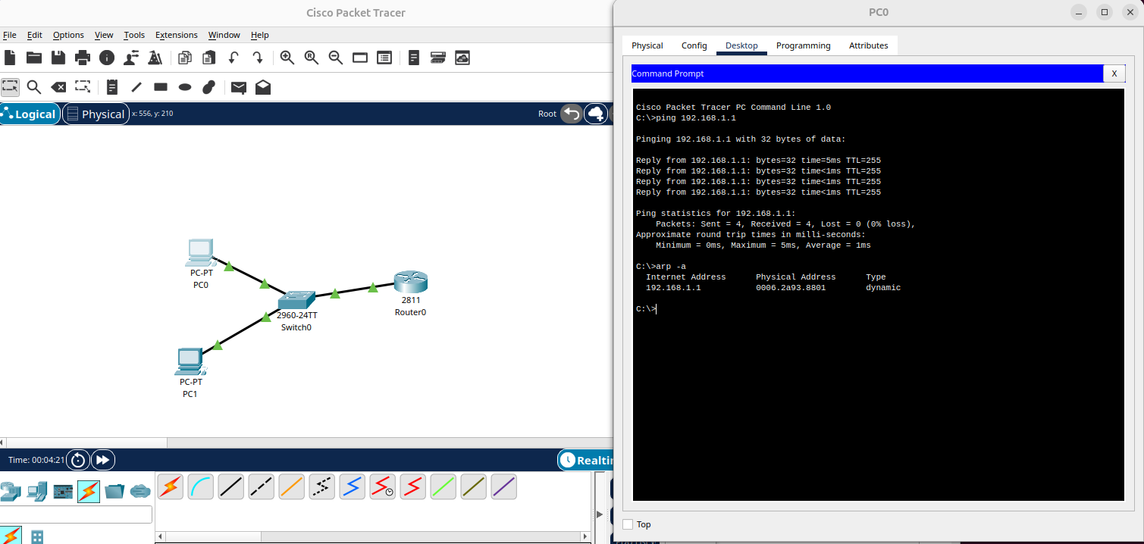

ARP Spoofing
- Enable Dynamic ARP Inspection (DAI) on the switch.
- Use Static ARP Entries on critical devices.
- Configure Port Security to limit MAC addresses per port.
- Use ARP Spoofing Detection tools.

